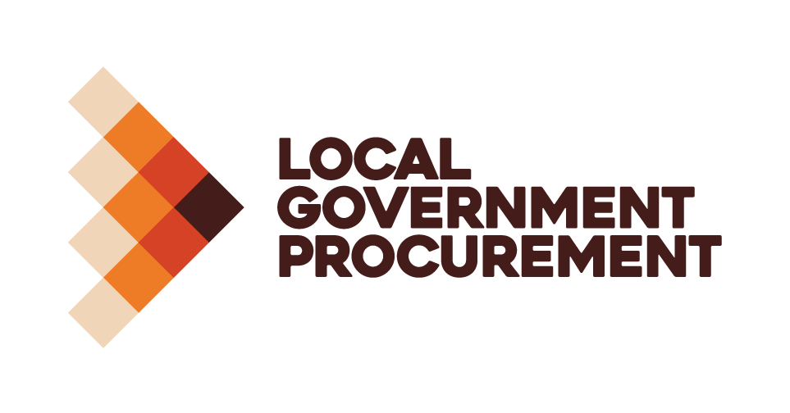

Call for Award Nominations
2023 LGP Contractor of the Year
Local Government Procurement (LGP) announces the LGP Contractor of the Year Award nominations are open.
As part of the Local Government Procurement Awards, LGP celebrates the diversity of our Approved Contractors and recognises their excellence in supporting the local government sector.
The award will reflect the company’s achievements specifically under the LGP contract, or contracts during the FY2022-23. Submissions will be assessed against the selection criteria below:
- Demonstrated introduction and/or application of sustainability initiatives
- Evidence of applied innovation - through the business, product or service
- Demonstrated commercial growth through the LGP contract
- Demonstrated promotion of the LGP contract or LGP with staff and buyers
- Demonstrate your achievements across the NSW local government sector under LGP contracts
The winner will be announced at the Local Government Procurement Conference dinner at Doltone House, Darling Island, Pyrmont. The awarded recipient will receive a personalised plaque and associated branding to promote the achievement.
Submit your self-nomination for the LGP Contractor of the Year Award
The criteria questions are outlined in the following pages, please complete the criteria for the award and email your submission to events@lgp.org.au
Closing date for entries is 5pm, Friday 15 September 2023.
For further information, please contact:
Michelle Burgess – Supplier Relationships Manager
M: 0455 081 845
Email: mburgess@lgp.org.au
Good luck!
LGP Contractor of the Year
To be eligible the Contractors’ products or service must be delivered under the LGP or NPN arrangement within the state of New South Wales.
Contractor Details
Company Name
Nominated Product or Service (if Applicable)
Nomination Submitted By
Name
Title
Relationship to Company
Phone
Email

Award Criteria Questions
The maximum word count, as a guide, is 300 words per question
- Please outline where your organisation has delivered sustainability initiatives (ie. environmental and/or social outcomes) under the LGP contract during FY2022-23.

- Tell us about how your company has implemented innovation under the contract. This can be innovative business practice, or the introduction of an innovative product or service?

- Can you please share with us what commercial growth your organisation has achieved during FY2022-23 through the LGP contract?

- Please demonstrate examples of how and where you have successfully promoted the LGP organisation and with your own staff, and with your council customers?

- Please outline what you believe to be the major achievements your organisation has delivered under the LGP contract, for the NSW local government sector. This can be any projects delivered, services provided or other outcomes which have made a difference?

- Please provide a summary of why you believe your company would be a worthy recipient of the LGP Contractor of the Year award?

- As part of your submission LGP welcome photos to tell your story (JPEG format) and /or a letter of support.
□ Please tick if attached
Next Step: Email your submission to events@lgp.org.au

